Lasso (Least Absolute Shrinkage and Selection Operator)

* Ability to shrink coefficient to zer == feature selection
* Penalize coefficient
* Sklearn.linear_model 🡺lasso
* Use standardScalar
* Fit_transform to xtrain
* Transform to xtest
* Alpha value to control the regularization strength
* Alpha value range 0.1
* Higher the value of alpha more the regularization
* Feature scaling is important in lasso
* Lasso.ceoeff_
* Mean square error, mean absolute error , r2error

**Mean Squared Error (MSE):**

* **Definition:** Measures the average squared difference between observed and predicted values.
* **Interpretation:** Lower MSE indicates better fit. Sensitive to outliers.
* **Formula:** MSE=1n∑i=1n(yi−y^i)2\text{MSE} = \frac{1}{n} \sum_{i=1}^{n} (y_i - \hat{y}_i)^2MSE=n1​∑i=1n​(yi​−y^​i​)2

**Mean Absolute Error (MAE):**

* **Definition:** Measures the average absolute difference between observed and predicted values.
* **Interpretation:** Lower MAE indicates better fit. Less sensitive to outliers compared to MSE.
* **Formula:** MAE=1n∑i=1n∣yi−y^i∣\text{MAE} = \frac{1}{n} \sum_{i=1}^{n} |y_i - \hat{y}_i|MAE=n1​∑i=1n​∣yi​−y^​i​∣

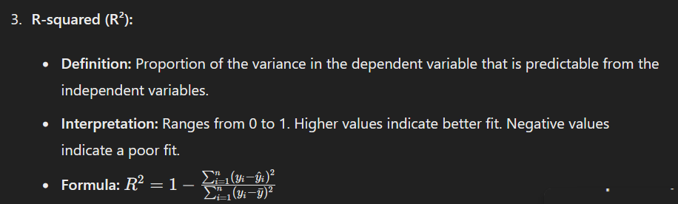

**When to Use What:**

* **MSE:** When you want to heavily penalize larger errors.
* **MAE:** When you want a measure less sensitive to outliers.
* **R²:** When you want to understand the proportion of variance explained by the model.

**Overfitting Prevention:** Regularization helps prevent overfitting.

**Interpretability:** Produces simpler and more interpretable models.

• Bias**:** Can introduce bias in the model estimates.

• Multicollinearity**:** Lasso may struggle with correlated features and might arbitrarily select one over the other.

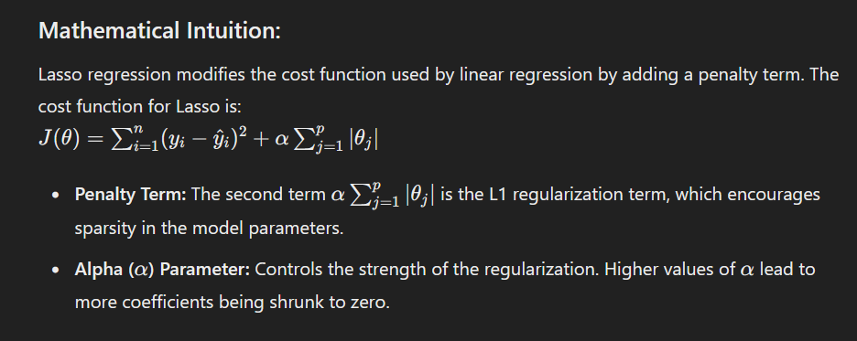

For Lasso and Ridge regression, the primary hyperparameter to tune is the regularization strength, controlled by the alpha parameter. perform hyperparameter tuning using cross-validation for both Lasso and Ridge regression models.

from sklearn.model_selection import train_test_split, GridSearchCV

lasso_params = {'alpha': np.logspace(-4, 4, 50)} ridge_params = {'alpha': np.logspace(-4, 4, 50)}

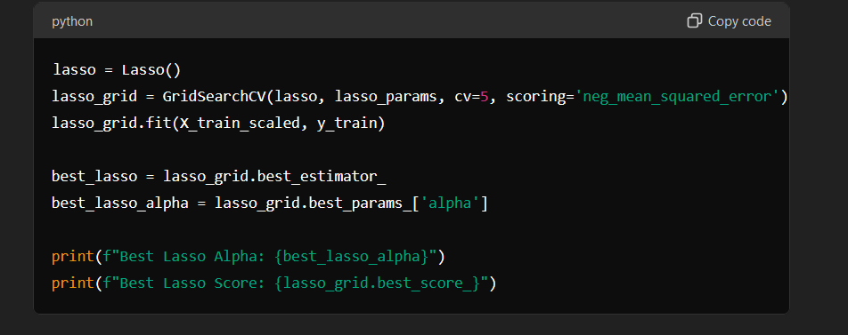

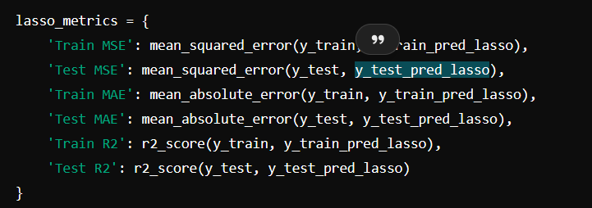

**Cross-Validation Score:**

* The best score from GridSearchCV gives an indication of the model’s performance during cross-validation. This helps in selecting the optimal alpha.

• **Mean Squared Error (MSE):** Lower values indicate better fit.

• **Mean Absolute Error (MAE):** Lower values indicate better fit.

• **R-squared (R²):** Higher values indicate better fit, representing the proportion of variance explained by the model.

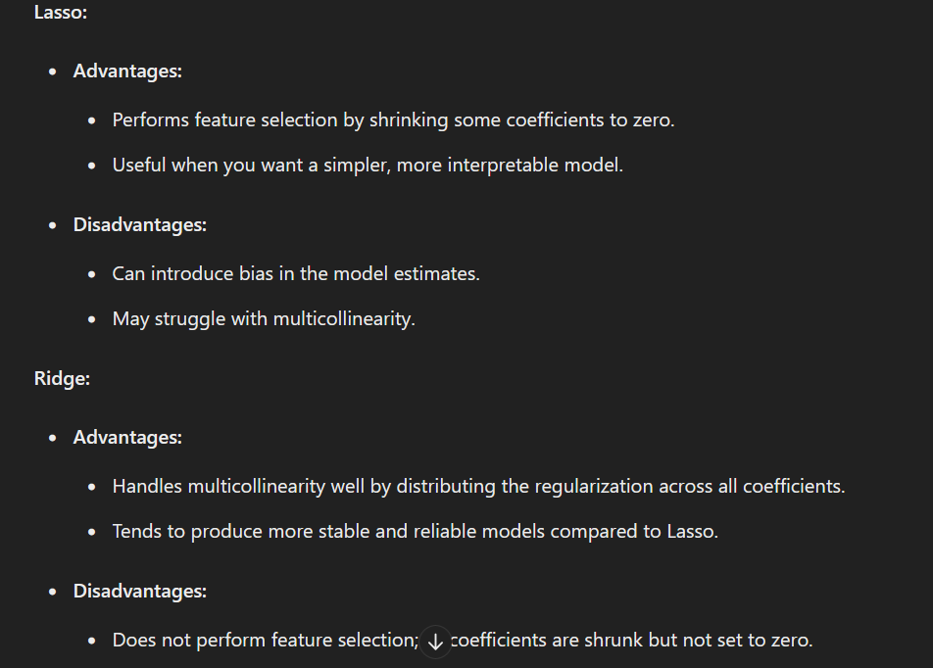

**Best Alpha:** The best alpha values for Lasso and Ridge regression are those that minimize the cross-validation error, providing a balance between bias and variance.

An R² value closer to 1 indicates that the model explains a large portion of the variance in the outcome variable.

• R² ranges from 0 to 1, with higher values indicating a better fit.

• R² = 1: The model perfectly explains all the variability of the target variable.

• R² = 0: The model does not explain any of the variability of the target variable.

• R² < 0: The model performs worse than a horizontal line (mean of the target variable).

**General Thresholds:**

* R² > 0.7: Indicates a strong fit.
* 0.5 < R² < 0.7: Indicates a moderate fit.
* R² < 0.5: Indicates a weak

**Why Use Polynomial Features?**

Linear regression assumes a linear relationship between the input variables (features) and the output variable (target). However, in many real-world scenarios, the relationship between the variables is not purely linear. Polynomial features transform the original features into higher-degree polynomials, enabling the model to capture non-linear relationships.

### How Polynomial Features Work:

For example, if you have a single feature xxx, polynomial features will generate new features like x2x^2x2, x3x^3x3, etc. For multiple features, it generates all possible combinations of the features up to a specified degree.

### Implementation with Code:

Here is a step-by-step guide on how to add polynomial features to your dataset and use them in a regression model.

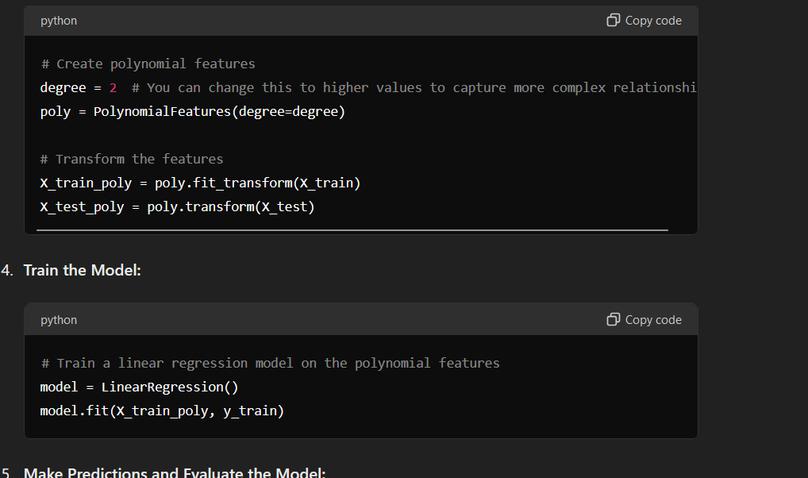

**Adjusting Polynomial Degree:**

* **Higher Degrees:** Captures more complex relationships but can lead to overfitting.
* **Lower Degrees:** Captures simpler relationships but might underfit the data.

**Feature Selection Techniques: Backward Elimination, Forward Selection, and Regularization**

Feature selection is an essential process in machine learning to improve model performance, reduce overfitting, and enhance interpretability. Here are three popular techniques for feature selection:

1. **Backward Elimination**
2. **Forward Selection**
3. **Regularization (Lasso Regression)**

**1. Backward Elimination**

**Explanation:**

* **Importance:** Backward elimination starts with all features and iteratively removes the least significant feature until a stopping criterion is met. It is useful for simplifying models and removing irrelevant features.
* **When to Use:** When you have a large number of features and want to identify a subset of features that contribute significantly to the model.

**1. Linear Regression**

**When to Use:**

* **Linear Relationship:** When you expect a linear relationship between the independent variables (features) and the dependent variable (target).
* **No Multicollinearity:** When there is little to no multicollinearity among the features.
* **Interpretability:** When you need a simple and interpretable model.

**2. Lasso Regression**

**When to Use:**

* **Feature Selection:** When you have a large number of features and suspect that only a few are actually relevant. Lasso can shrink the coefficients of less important features to zero, effectively performing feature selection.
* **Sparse Models:** When you want a sparse model that highlights the most significant predictors.
* **Preventing Overfitting:** When you want to prevent overfitting but also perform feature selection.

**3. Ridge Regression**

**When to Use:**

* **Multicollinearity:** When you have multicollinearity among the features. Ridge regression handles multicollinearity by adding a penalty on the size of the coefficients.
* **All Features Relevant:** When you believe that all the features might contribute to the target variable, but their effects need to be regularized to prevent overfitting.
* **Preventing Overfitting:** When you want to prevent overfitting without necessarily performing feature selection.

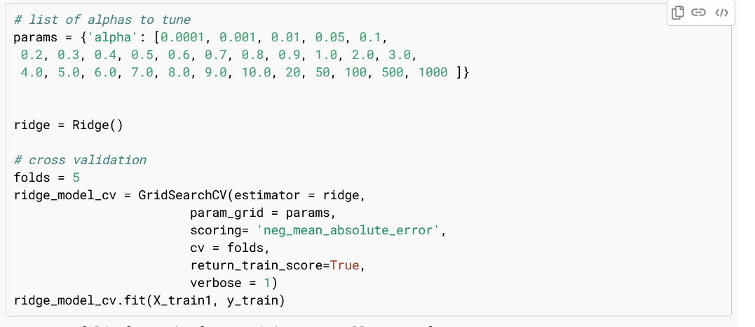

**Recursive Feature Elimination (RFE)**

**Explanation:**

Recursive Feature Elimination (RFE) is a feature selection method that recursively removes the least important features from the model to select the most significant subset of features. The process involves the following steps:

1. **Train the Model:** Fit the model to the training data.
2. **Rank Features:** Rank the importance of each feature using a coefficient or importance metric from the fitted model.
3. **Eliminate Least Important Feature:** Remove the least important feature.
4. **Repeat:** Repeat the process until the desired number of features is reached.

**When to Use RFE:**

* When you want to reduce the number of features to prevent overfitting.
* When you aim to improve model performance by eliminating irrelevant or redundant features.
* When interpretability is important, and you need a simpler model with fewer features.

**Purpose:**

The primary purpose of RFE is to improve the performance and generalization of a model by selecting the most important features. It helps in creating a more interpretable model and reducing computational costs.

From sklearn,feature_selection import RFE

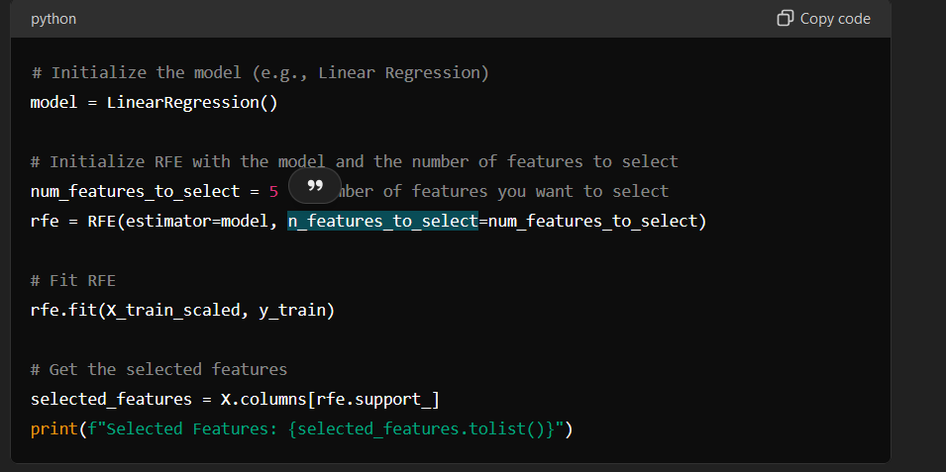

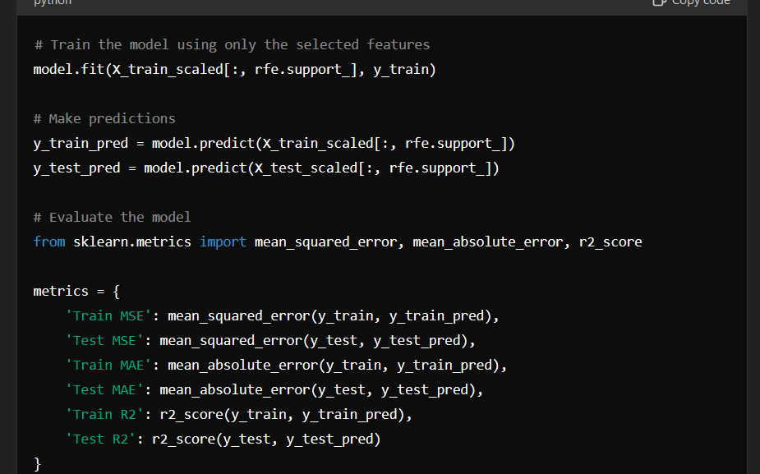

**Benefits of RFE:**

* **Improved Performance:** By selecting the most important features, RFE can improve the performance of the model.
* **Reduced Overfitting:** Eliminating irrelevant or redundant features helps in reducing overfitting.
* **Simplified Model:** A simpler model with fewer features is easier to interpret and can reduce computational costs.

**When Not to Use RFE:**

* **Large Datasets:** RFE can be computationally expensive for very large datasets with many features.
* **Non-linear Relationships:** If the underlying relationships between features and the target variable are highly non-linear, RFE with linear models might not be effective. Consider using RFE with more complex models or other feature selection techniques.

1. **What is linear regression?**
   * Linear regression is a statistical method used to model the relationship between a dependent variable and one or more independent variables by fitting a linear equation to the observed data.
2. **What are the assumptions of linear regression?**
   * Linearity: The relationship between the independent and dependent variables is linear.
   * Independence: Observations are independent of each other.
   * Homoscedasticity: Constant variance of errors.
   * Normality: The residuals of the model are normally distributed.
   * No multicollinearity: Independent variables are not highly correlated.
3. **How do you interpret the coefficients in a linear regression model?**
   * Each coefficient represents the change in the dependent variable for a one-unit change in the corresponding independent variable, holding other variables constant.
4. **What is the difference between simple linear regression and multiple linear regression?**
   * Simple linear regression uses one independent variable to predict a dependent variable, while multiple linear regression uses two or more independent variables.
5. **What is multicollinearity and how can it be detected?**
   * Multicollinearity occurs when independent variables are highly correlated. It can be detected using Variance Inflation Factor (VIF) or correlation matrices.
6. **How can you address multicollinearity in a regression model?**
   * Remove one of the correlated variables.
   * Combine the correlated variables into a single predictor.
   * Use regularization techniques like Ridge regression.
7. **What is the purpose of the R-squared value in linear regression?**
   * R-squared measures the proportion of the variance in the dependent variable that is predictable from the independent variables. It ranges from 0 to 1, with higher values indicating better model fit.
8. **What is the adjusted R-squared value?**
   * Adjusted R-squared adjusts the R-squared value based on the number of predictors in the model. It penalizes the addition of non-significant predictors and provides a more accurate measure of model fit.
9. **What are residuals in a regression model?**
   * Residuals are the differences between the observed values and the predicted values. They represent the error in the model.
10. **How can you check for the normality of residuals?**
    * Use visual methods like Q-Q plots or statistical tests like the Shapiro-Wilk test.

#### Advanced Questions on Linear Regression

1. **What is the difference between correlation and regression?**
   * Correlation measures the strength and direction of the relationship between two variables, while regression quantifies the relationship and makes predictions.
2. **How do you handle outliers in a regression model?**
   * Outliers can be handled by removing them, transforming the variables, or using robust regression methods.
3. **What is heteroscedasticity and how can it be detected?**
   * Heteroscedasticity occurs when the variance of residuals is not constant. It can be detected using visual methods like residual plots or statistical tests like the Breusch-Pagan test.
4. **How can you address heteroscedasticity in a regression model?**
   * Use transformations like log or square root.
   * Use weighted least squares regression.
5. **What is the F-test in the context of regression?**
   * The F-test assesses the overall significance of the regression model. It tests whether at least one predictor variable has a non-zero coefficient.
6. **What is the difference between an F-test and a t-test in regression?**
   * The F-test evaluates the overall significance of the model, while the t-test assesses the significance of individual coefficients.
7. **What is stepwise regression?**
   * Stepwise regression is a method of fitting regression models in which predictors are added or removed based on their statistical significance in a series of iterative steps.
8. **What is regularization and why is it useful?**
   * Regularization techniques like Ridge and Lasso add a penalty to the regression model to prevent overfitting and improve generalization by shrinking the coefficients.
9. **How do you evaluate the performance of a regression model?**
   * Use metrics like Mean Squared Error (MSE), Mean Absolute Error (MAE), and R-squared. Cross-validation can also be used to assess model performance.
10. **What is cross-validation and why is it important?**
    * Cross-validation is a technique for assessing how a model generalizes to an independent dataset. It helps to detect overfitting and provides a more reliable estimate of model performance.

#### Questions on Ridge Regression

1. **What is Ridge regression?**
   * Ridge regression, also known as Tikhonov regularization, is a type of linear regression that includes a regularization term (L2 penalty) to shrink the coefficients and prevent overfitting.
2. **How does the L2 penalty work in Ridge regression?**
   * The L2 penalty adds the sum of the squared coefficients to the cost function, penalizing large coefficients and reducing model complexity.
3. **When should you use Ridge regression?**
   * Use Ridge regression when there is multicollinearity among the independent variables, or when you want to prevent overfitting.
4. **What is the Ridge regression cost function?**
   * The cost function for Ridge regression is: J(θ)=∑(yi−y^i)2+α∑θj2J(\theta) = \sum (y_i - \hat{y}_i)^2 + \alpha \sum \theta_j^2J(θ)=∑(yi​−y^​i​)2+α∑θj2​, where α\alphaα is the regularization parameter.
5. **How do you choose the regularization parameter (alpha) in Ridge regression?**
   * The regularization parameter can be chosen using cross-validation to find the value that minimizes the validation error.
6. **What are the advantages of Ridge regression?**
   * Reduces overfitting.
   * Handles multicollinearity.
   * Improves model generalization.
7. **What are the limitations of Ridge regression?**
   * Does not perform feature selection (all coefficients are shrunk but not set to zero).
   * Can be computationally expensive for very large datasets.
8. **How does Ridge regression differ from ordinary least squares (OLS) regression?**
   * Ridge regression adds a regularization term to the cost function, while OLS does not. This helps Ridge regression to handle multicollinearity and prevent overfitting.
9. **How do you implement Ridge regression in Python?**
   * Use the Ridge class from sklearn.linear_model. Example:

python

1. **What is the impact of increasing the alpha parameter in Ridge regression?**
   * Increasing alpha increases the penalty on the coefficients, leading to smaller coefficients and potentially underfitting. Decreasing alpha reduces the penalty, leading to larger coefficients and potentially overfitting.

#### Questions on Lasso Regression

1. **What is Lasso regression?**
   * Lasso (Least Absolute Shrinkage and Selection Operator) regression is a type of linear regression that includes a regularization term (L1 penalty) to shrink coefficients and perform feature selection.
2. **How does the L1 penalty work in Lasso regression?**
   * The L1 penalty adds the absolute value of the coefficients to the cost function, encouraging some coefficients to be exactly zero and thus performing feature selection.
3. **When should you use Lasso regression?**
   * Use Lasso regression when you want to perform feature selection and shrink less important coefficients to zero.
4. **What is the Lasso regression cost function?**
   * The cost function for Lasso regression is: J(θ)=∑(yi−y^i)2+α∑∣θj∣J(\theta) = \sum (y_i - \hat{y}_i)^2 + \alpha \sum |\theta_j|J(θ)=∑(yi​−y^​i​)2+α∑∣θj​∣, where α\alphaα is the regularization parameter.
5. **How do you choose the regularization parameter (alpha) in Lasso regression?**
   * The regularization parameter can be chosen using cross-validation to find the value that minimizes the validation error.
6. **What are the advantages of Lasso regression?**
   * Performs feature selection.
   * Reduces overfitting.
   * Improves model interpretability.
7. **What are the limitations of Lasso regression?**
   * Can lead to biased estimates.
   * Can perform poorly when the number of predictors is greater than the number of observations.
8. **How does Lasso regression differ from ordinary least squares (OLS) regression?**
   * Lasso regression adds a regularization term to the cost function, which can shrink some coefficients to zero and perform feature selection, while OLS does not.
9. **How do you implement Lasso regression in Python?**
   * Use the Lasso class from sklearn.linear_model. Example:

python

1. **What is the impact of increasing the alpha parameter in Lasso regression?**
   * Increasing alpha increases the penalty on the coefficients, leading to more coefficients being shrunk to zero. Decreasing alpha reduces the penalty, leading to fewer coefficients being shrunk to zero.

#### Advanced Questions on Ridge and Lasso Regression

1. **How do Ridge and Lasso regression handle multicollinearity?**
   * Ridge regression reduces the impact of multicollinearity by adding a penalty on the size of the coefficients. Lasso regression can also help by performing feature selection and shrinking some coefficients to zero.
2. **What is Elastic Net regression?**
   * Elastic Net regression combines both L1 (Lasso) and L2 (Ridge) penalties. It is useful when there are multiple features correlated with each other.
3. **When should you use Elastic Net regression?**
   * Use Elastic Net when you want to combine the benefits of both Lasso (feature selection) and Ridge (handling multicollinearity) regression.
4. **What is the cost function for Elastic Net regression?**
   * The cost function for Elastic Net regression is: J(θ)=∑(yi−y^i)2+α1∑∣θj∣+α2∑θj2J(\theta) = \sum (y_i - \hat{y}_i)^2 + \alpha_1 \sum |\theta_j| + \alpha_2 \sum \theta_j^2J(θ)=∑(yi​−y^​i​)2+α1​∑∣θj​∣+α2​∑θj2​.
5. **How do you implement Elastic Net regression in Python?**
   * Use the ElasticNet class from sklearn.linear_model. Example:

python

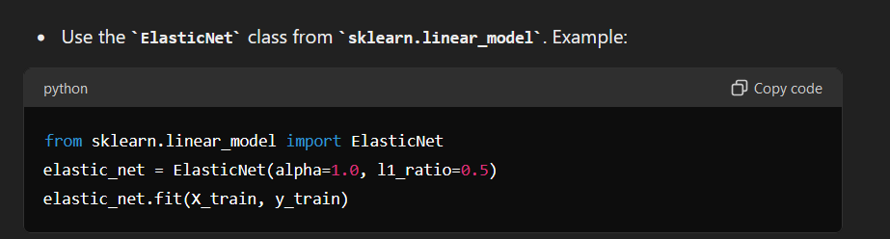

1. **What is the l1_ratio parameter in Elastic Net regression?**
   * The l1_ratio parameter determines the balance between L1 and L2 regularization. A ratio of 0 corresponds to Ridge regression, while a ratio of 1 corresponds to Lasso regression.
2. **What are some common techniques to handle missing data in regression models?**
   * Imputation (mean, median, mode, or using predictive models).
   * Removal of rows or columns with missing data.
   * Using algorithms that support missing data handling.
3. **How do you deal with categorical variables in regression models?**
   * Convert categorical variables to numerical using techniques like one-hot encoding, label encoding, or target encoding.
4. **What is the purpose of standardizing or normalizing features in regression models?**
   * Standardizing or normalizing features ensures that they are on a similar scale, which is important for algorithms that are sensitive to feature scaling (e.g., regularized regression models).
5. **How do you detect and address overfitting in regression models?**
   * Use cross-validation to detect overfitting.
   * Apply regularization techniques like Ridge or Lasso.
   * Simplify the model by reducing the number of features.

#### Real-World Application Questions

1. **How would you approach building a regression model for predicting house prices?**
   * Collect and preprocess the data (handling missing values, encoding categorical variables, scaling features).
   * Perform exploratory data analysis to understand relationships and distributions.
   * Split the data into training and test sets.
   * Start with a simple linear regression model and evaluate performance.
   * Apply regularization techniques like Ridge or Lasso if necessary.
   * Tune hyperparameters using cross-validation.
   * Evaluate the final model on the test set.
2. **Describe a situation where you would prefer Lasso regression over Ridge regression.**
   * Prefer Lasso regression when feature selection is important and you want a sparse model with some coefficients shrunk to zero.
3. **Describe a situation where you would prefer Ridge regression over Lasso regression.**
   * Prefer Ridge regression when you have multicollinearity among the features and want to include all features in the model, but regularize their impact to prevent overfitting.
4. **How would you handle a regression problem with a large number of features?**
   * Perform feature selection using methods like Lasso regression or backward elimination.
   * Use dimensionality reduction techniques like Principal Component Analysis (PCA).
   * Apply regularization techniques to handle multicollinearity and overfitting.
5. **How would you explain the concept of regularization to a non-technical stakeholder?**
   * Regularization is a technique used to prevent overfitting by adding a penalty to the complexity of the model. It helps ensure that the model performs well on new, unseen data by avoiding overly complex models that fit the training data too closely.
6. **What are some common pitfalls to avoid when using regression models?**
   * Not checking for and addressing multicollinearity.
   * Ignoring assumptions of linear regression.
   * Overfitting the model to the training data.
   * Failing to properly preprocess the data (e.g., handling missing values, scaling features).
7. **How do you assess the importance of features in a regression model?**
   * Look at the magnitude and significance of the coefficients.
   * Use feature importance scores from regularized regression models.
   * Perform feature selection techniques like backward elimination or forward selection.
8. **What are the advantages and disadvantages of using polynomial regression?**
   * Advantages: Can model non-linear relationships, more flexible than linear regression.
   * Disadvantages: Can lead to overfitting, higher computational complexity, more difficult to interpret.
9. **How would you approach a regression problem with time series data?**
   * Check for stationarity and apply transformations if necessary.
   * Use lagged variables as predictors.
   * Consider using time series-specific models like ARIMA or SARIMA.
   * Ensure proper cross-validation by using time-based splits.
10. **Explain the concept of bias-variance tradeoff in the context of regression models.**
    * Bias-variance tradeoff is the balance between the error due to bias (error from wrong assumptions) and variance (error from sensitivity to small fluctuations in the training set). High bias can lead to underfitting, while high variance can lead to overfitting. Regularization techniques like Ridge and Lasso help manage this tradeoff by adding a penalty to model complexity.

asso regression, or Least Absolute Shrinkage and Selection Operator, is a type of linear regression that uses shrinkage, where data values are shrunk towards a central point, like the mean. It is particularly useful when dealing with data that has a large number of predictors. The key difference between Lasso regression and standard linear regression is the addition of a penalty to the regression coefficients, which leads to feature selection and can improve the model's prediction accuracy and interpretability.

## Mathematical Formulation

The objective function in Lasso regression includes a penalty term that is proportional to the sum of the absolute values of the coefficients. This penalty can drive some coefficients to be exactly zero, leading to a sparse model.

Given a dataset with nnn observations and ppp predictors, the Lasso regression model is defined as:

y=Xβ+ϵy = X \beta + \epsilony=Xβ+ϵ

where:

* yyy is the vector of observed values.
* XXX is the matrix of predictors.
* β\betaβ is the vector of regression coefficients.
* ϵ\epsilonϵ is the error term.

### Objective Function

The Lasso regression objective function can be written as:

min⁡β{12n∑i=1n(yi−∑j=1pXijβj)2+λ∑j=1p∣βj∣}\min_{\beta} \left\{ \frac{1}{2n} \sum_{i=1}^{n} \left( y_i - \sum_{j=1}^{p} X_{ij} \beta_j \right)^2 + \lambda \sum_{j=1}^{p} |\beta_j| \right\}minβ​{2n1​∑i=1n​(yi​−∑j=1p​Xij​βj​)2+λ∑j=1p​∣βj​∣}

where:

* 12n∑i=1n(yi−∑j=1pXijβj)2\frac{1}{2n} \sum_{i=1}^{n} \left( y_i - \sum_{j=1}^{p} X_{ij} \beta_j \right)^22n1​∑i=1n​(yi​−∑j=1p​Xij​βj​)2 is the residual sum of squares (RSS).
* λ∑j=1p∣βj∣\lambda \sum_{j=1}^{p} |\beta_j|λ∑j=1p​∣βj​∣ is the penalty term.
* λ\lambdaλ is a non-negative tuning parameter that controls the strength of the penalty.

### Key Concepts

1. **Shrinkage**: As λ\lambdaλ increases, the penalty on the coefficients increases, causing the estimated coefficients to shrink towards zero.
2. **Sparsity**: For sufficiently large values of λ\lambdaλ, some coefficients are exactly zero, effectively performing variable selection.
3. **Bias-Variance Trade-off**: By introducing bias (through the penalty term), Lasso regression can reduce the variance of the model, potentially leading to better prediction performance on new data.

### Solution

The Lasso problem does not have a closed-form solution due to the ℓ1\ell_1ℓ1​ norm in the penalty term. Instead, it is typically solved using iterative algorithms such as coordinate descent or Least Angle Regression (LARS).

### Example

Consider a simple linear regression model with two predictors:

y=β0+β1x1+β2x2+ϵy = \beta_0 + \beta_1 x_1 + \beta_2 x_2 + \epsilony=β0​+β1​x1​+β2​x2​+ϵ

The Lasso regression objective function for this model is:

min⁡β0,β1,β2{12n∑i=1n(yi−β0−β1x1i−β2x2i)2+λ(∣β1∣+∣β2∣)}\min_{\beta_0, \beta_1, \beta_2} \left\{ \frac{1}{2n} \sum_{i=1}^{n} \left( y_i - \beta_0 - \beta_1 x_{1i} - \beta_2 x_{2i} \right)^2 + \lambda (|\beta_1| + |\beta_2|) \right\}minβ0​,β1​,β2​​{2n1​∑i=1n​(yi​−β0​−β1​x1i​−β2​x2i​)2+λ(∣β1​∣+∣β2​∣)}

By solving this optimization problem, we obtain the estimates of β0,β1,\beta_0, \beta_1,β0​,β1​, and β2\beta_2β2​ that minimize the residual sum of squares subject to the ℓ1\ell_1ℓ1​ penalty.

### Properties

1. **Feature Selection**: Lasso can select a subset of features by shrinking some coefficients to exactly zero.
2. **Collinearity Handling**: In the presence of highly correlated predictors, Lasso tends to select one and ignore the others, thus reducing multicollinearity.
3. **Interpretability**: By producing sparse models, Lasso can make models more interpretable.

### Advantages and Disadvantages

**Advantages:**

* Can perform feature selection and thus improve model interpretability.
* Can handle multicollinearity among predictors.
* Can improve prediction accuracy by reducing overfitting.

**Disadvantages:**

* The choice of λ\lambdaλ is critical and typically determined via cross-validation.
* It may not perform well if the number of predictors is much larger than the number of observations.
* It can sometimes be too aggressive in shrinking coefficients, especially if the true model has many small but non-zero coefficients.

asso regression is particularly valuable in several scenarios, and its importance stems from its ability to handle specific challenges in predictive modeling. Here are the main reasons why Lasso regression is needed, scenarios in which to use it, and why it is important:

## Why Lasso Regression is Needed

1. **High-Dimensional Data**: In situations where the number of predictors (features) is large relative to the number of observations, Lasso regression helps by shrinking some coefficients to zero, effectively performing feature selection and reducing the model complexity.
2. **Multicollinearity**: When predictors are highly correlated, Lasso can help by selecting one predictor among the correlated ones and shrinking others to zero, thus mitigating the issue of multicollinearity.
3. **Interpretability**: By producing sparse models, Lasso regression makes it easier to interpret which predictors are driving the response, which is particularly useful in fields like genomics, finance, and social sciences where understanding the underlying process is crucial.
4. **Overfitting Prevention**: By adding a penalty to the regression coefficients, Lasso regression reduces the risk of overfitting, especially when dealing with complex models or noisy data.

## Scenarios to Use Lasso Regression

1. **Feature Selection**: When you have a large number of features and you want to identify the most important ones. Lasso can automatically exclude less important features by shrinking their coefficients to zero.
2. **Predictive Modeling with High-Dimensional Data**: In fields like genetics, text processing, and finance where datasets often have a large number of variables, Lasso helps by simplifying the model and improving prediction accuracy.
3. **Models with Multicollinearity**: When predictors are highly correlated, Lasso can help by reducing the impact of multicollinearity and selecting a subset of the predictors.
4. **Improving Model Generalization**: When you want to improve the generalization of your model to new data by reducing overfitting, Lasso regression's regularization term can help achieve this.

## Importance of Lasso Regression

1. **Enhanced Model Performance**: By reducing overfitting, Lasso regression can improve the predictive performance of the model on new data, leading to better generalization.
2. **Automatic Feature Selection**: Lasso's ability to shrink some coefficients to zero simplifies the model and helps in identifying the most relevant predictors, which is crucial for model interpretation and insights.
3. **Handling High-Dimensionality**: In modern datasets with high-dimensionality, traditional regression methods can struggle. Lasso provides a practical approach to manage such data effectively.
4. **Robustness to Noise**: Lasso regression can handle noisy data better than traditional regression models by reducing the impact of less important or noisy features.

The choice of metrics to evaluate a Lasso regression model depends on the specific context and goals of the analysis. However, some metrics are more commonly used than others due to their general applicability and ease of interpretation. Here are the most commonly used metrics:

**1. Mean Squared Error (MSE)**

* **Why Used**: MSE is widely used because it penalizes larger errors more significantly than smaller ones, providing a comprehensive measure of model performance.
* **When Used**: Commonly used in regression tasks for both training and test datasets to evaluate the overall performance of the model.

**2. Root Mean Squared Error (RMSE)**

* **Why Used**: RMSE is preferred when you want the error metric to be in the same units as the target variable, making it more interpretable.
* **When Used**: Frequently used alongside MSE, especially in contexts where the magnitude of the error is important to interpret.

**3. Mean Absolute Error (MAE)**

* **Why Used**: MAE is less sensitive to outliers compared to MSE and RMSE, providing a more robust measure of prediction accuracy.
* **When Used**: Used when you want to understand the average magnitude of errors without squaring them, especially in the presence of outliers.

**4. R-squared (R²)**

* **Why Used**: R² provides a measure of how well the predictors explain the variability of the response variable, making it a useful metric for model interpretability.
* **When Used**: Commonly used to assess the overall fit of the model and compare it to other models.

**5. Adjusted R-squared**

* **Why Used**: Adjusted R² adjusts for the number of predictors in the model, providing a more accurate measure of model performance, especially when comparing models with different numbers of predictors.
* **When Used**: Used when comparing models with varying numbers of predictors to prevent overfitting.

**6. Cross-Validation Metrics (e.g., Cross-Validation MSE or RMSE)**

* **Why Used**: Cross-validation provides a robust measure of model performance by evaluating it on multiple subsets of the data, reducing the risk of overfitting.
* **When Used**: Used during model selection and hyperparameter tuning to ensure the model generalizes well to unseen data.

Cross-validation is a technique used to assess the performance and generalizability of a machine learning model. It helps ensure that the model performs well on unseen data by providing a more robust estimate of model performance compared to a simple train-test split. Here is a detailed explanation of cross-validation, its types, benefits, and practical implementation.

### What is Cross-Validation?

Cross-validation involves dividing the dataset into multiple subsets (or folds) and training and validating the model on these folds in various ways. The most common form of cross-validation is k-fold cross-validation.

### Key Concepts

1. **Training Set**: The subset of data used to train the model.
2. **Validation Set**: The subset of data used to evaluate the model's performance during training.
3. **Test Set**: A separate subset of data used for final evaluation after the model has been trained and validated.

### Types of Cross-Validation

#### 1. K-Fold Cross-Validation

* **Procedure**:
  + The dataset is randomly divided into k equally sized folds.
  + The model is trained on k-1 folds and validated on the remaining fold.
  + This process is repeated k times, each time with a different fold as the validation set.
  + The final performance metric is the average of the performance across all k folds.
* **Benefits**:
  + Reduces the variance of the performance estimate.
  + Uses the entire dataset for both training and validation.
* **Implementation**:

